**RECESS/LUNCH**

During the 2025-26 school year, 6th graders will have their recess before their lunch. The Recess/Lunch block will be from 12:40-1:40.

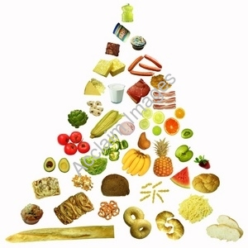

Each morning, students will be given an opportunity to eat a healthy snack. Snacks and drinks are to be provided by the student, and due to the increasing number of food allergies among children, may not be shared.

Due to food allergies, please do not send any peanut, tree nut, or nutseed products in for snack. Thank you!